Budget Rent A Car 
of British Columbia

Global Information System

Separate Accessory Sales Business Design

Version 2.00

Note: The information contained in this document is confidential and may not be disclosed to any parties outside of Budget Rent a Car of British Columbia without written consent by one of its officers.
Copyright (C) 2000 Budget Rent a Car of British Columbia
Table of Contents
1. Functional Area Business Design 1
1.1. Contracts 1
1.1.1. Screens 1
1.1.1.1. Accessory Sales Screen 1
2. Revision History 13
2.1. Version 2.00 13

Functional Area Business Design

Contracts

Screens

Accessory Sales Screen
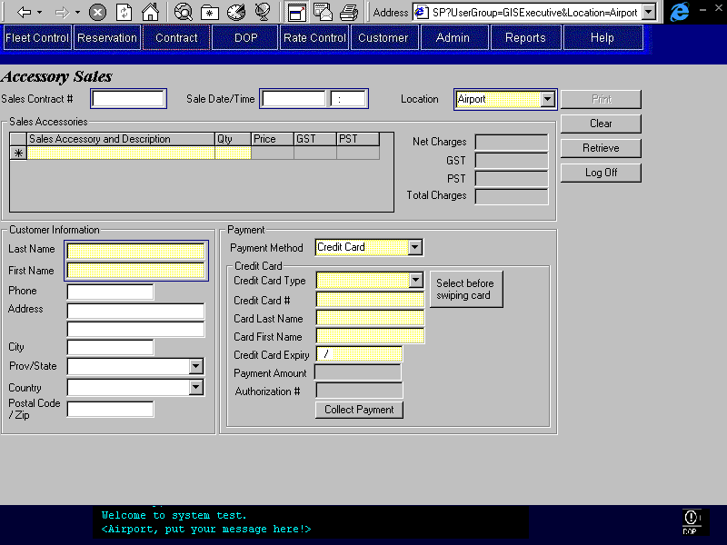
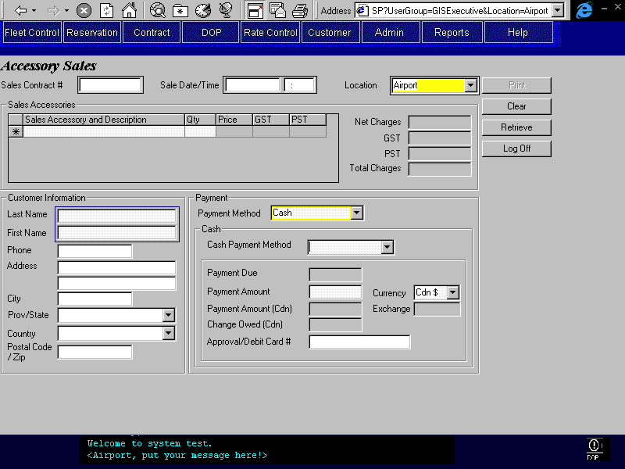
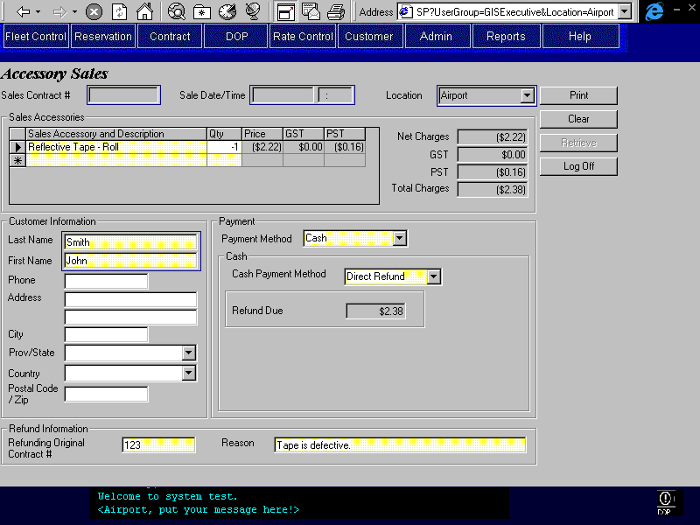
Purpose
This screen allows for the sale of accessories independent of a vehicle rental. The CSR will select sales accessories to be sold and enter the quantity of each selected sales accessory. GIS will calculate the price and applicable taxes from the sales accessory definitions entered in the Sales Accessory Maintenance screen. There is no ability to override the price or taxes in this screen. The CSR will then enter Customer Information and Payment Information. Sales accessories may be paid for by credit card or cash (the same cash sub-types as in Contract Open/Check Out). Printing the sales receipt will save the contract and provide a receipt for the customer. Upon saving, a Sales Contract # will be generated and the date and time of sale recorded. A sales contract cannot be updated once it is saved.
In the event a refund is required, the CSR may enter a negative sales contract. A negative sale contract is any sale that has a negative quantity. A mix of negative and positive quantities is not allowed. When a negative number is entered in the Quantity field the Refund Information will become visible and the CSR will be required to enter the Refunding Original Contract # and the Reason for the refund. If the sale date and time of the original contract being refunded is not within the same RBR date as the current time then the negative sales will not be allowed. Once the negative sales quantities are entered, the CSR will enter the payment method. The payment methods allowed for negative sales are credit card and cash. Cash refund subtypes are mail refund and direct refund. For credit card payment the refund process must be successful before the sales receipt can be saved and printed. If the credit card refund cannot be completed then the CSR will have to switch the payment method to cash.
There may be more than one negative sales contract per original sales contract, however, the total amount refunded by all the negative sales contracts cannot be greater than the amount charged by the original sales contract. For original sales contracts where a negative sales contract has refunded part or all of the sale, the Refunded by Contract # (negative contract #) will be displayed. In this case, the Refund Information will be automatically visible.
If required the CSR may retrieve existing sales contracts by entering data in some or all of Sales Contract #, Sale Date/Time, Location, Customer Last Name, and Customer First Name fields. If more than one Sales Contract is found based on the search criteria, a search results list will be displayed that will include the search fields mentioned above and the sales dollar amount. From this list the CSR may select the sales contract to view. An existing sales contract cannot be updated, it may only be viewed or have its receipt printed.
Navigation
N/A
Functions
Print: For new Accessory Sales Contracts, saves and prints the receipt. For existing Accessory Sales Contracts prints receipt. Printed receipts will be sequenced for the same sales contract. See the Separate Accessory Sales Receipt report design document.
Enable Clear button if previously disabled.
Clear: Clears screen. Disabled after a Credit Card payment has been collected.
Re-enable the Retrieve button.
Save: Invoked by the Print button and the Collect/Refund button. Creates Accessory Sales Contract and locks all fields. Completes the following edits:
- Sales quantities must all be either positive or negative, a mixture is not allowed.
- If payment method is credit card, check that the payment or refund has been successfully processed as described in the Credit Card Interface document. If not alert CSR and do not complete save.
- If a negative sales contract then check that for all related negative sales contracts, the total refunded is not greater than the total charged for the original sales contract.
Retrieve: Retrieves existing Accessory Sales Contracts based on the Sales Contract #, Sales Date/Time, Location, Customer Last Name and First Name. Once retrieved, an existing sales contract may only be viewed or have its receipt printed.
Disabled when a sales accessory is selected.
Collect/Refund Saves the Accessory Sales Contract, collects payment for the credit card and
Payment: captures the amount specified on the screen. For details on the credit
(Credit Card) card payment process, see the Credit Card Interface document. Note that the save function is only invoked if the credit card transaction is successful.
If the automated payment facility is not available or the credit card type has no automatic payment, opens the Manual Credit Card Transaction sub-screen and populates it with the credit card and payment amount information. After the sub-screen is closed, the authorization number returned will be displayed on this screen.
Disabled after Collect Payment completed.
The text on the button is Refund Payment if payment amount is negative, otherwise the text is Collect Payment.
Clear button is disabled until sales contract is printed.
Generates Accounting Interface entries for the payment. For details, see the section on Accounting Interface Entries for Separate Accessory Sales in the Contract Part I document.
Controls
Req*: Y – always mandatory
N – always optional
S – sometime optional (see Comments for details)
D – display only
Field | Source | Req* | Validation | Comments
Sales Contract # | Sales Accessory Sale Contract, Sales Contract Number | D |  | Unlocked when the screen is first opened or when the screen has been cleared using Clear. Locked when the screen has been populated using the Retrieve button. Cleared and locked when a sales accessory is selected.  Automatically populated upon saving contract.
Sale Date/Time | Sales Accessory Sale Contract, Sale Date/Time | D | Date/Time | Unlocked when the screen is first opened or when the screen has been cleared using Clear. Locked when the screen has been populated using the Retrieve button. Cleared and locked when a sales accessory is selected.  Current date/time is saved when sales contract created.
Location | Sales Accessory Sale Contract, Sold at Location ID | Y | Value controlled by location table, BRAC locations only. | Unlocked when the screen is first opened or when the screen has been cleared using Clear. Locked when the screen has been populated using the Retrieve button. Defaulted to current location and locked when a sales accessory is selected.  Save as current location when contract created.
Sales Accessory
Sales Accessory | Sales Accessory Sale Item, Sales Accessory ID | Y | Value controlled by Location Sales Accessory table. | Display Sales Accessory Name and Unit Description.  At lease one sales accessory must be selected to save the sales contract.
Quantity | Sales Accessory Sale Item, Quantity | S | Numeric | Required if Sales Accessory selected. Default to 1.
Price | Sales Accessory Sale Item, Amount | D |  | Calculated based on quantity and Location Sales Accessory, Price (if null then use Sales Accessory Price, Price).
GST | Sales Accessory Sale Item, GST Amount | D |  | Item price * GST rate if GST not exempt for selected sales accessory.
PST | Sales Accessory Sale Item, PST Amount | D |  | Item price * GST rate if GST not exempt for selected sales accessory.
Net Charges |  | D |  | Sum of prices for all selected sales accessories.
GST |  | D |  | Sum of (price * GST) if GST not exempt for selected sales accessory
PST |  | D |  | Sum of (price * PST) if PST not exempt for selected sales accessory
Total Charges |  | D |  | Sum of Net Charges, GST, and PST.
Customer Information
Last Name | Sales Accessory Sale Contract, Last Name | Y | Free text | Same as credit card last name. If credit card last name is populated, will overwrite information in this field.
First Name | Sales Accessory Sale Contract, First Name | Y | Free text | Same as credit card first name. If credit card first name is populated, will overwrite information in this field.
Phone Number | Sales Accessory Sale Contract, Phone Number | S |  | Required if Payment Type is Mail Refund
Address 1 | Sales Accessory Sale Contract, Address1 | S | Free text | Required if Payment Type is Mail Refund
Address 2 | Sales Accessory Sale Contract, Address2 | S | Free text
City | Sales Accessory Sale Contract, City | S | Free text | Required if Payment Type is Mail Refund
Province/State | Sales Accessory Sale Contract, Province | S | Entry assisted by Province table. Must be a valid value if country is US or Canada. | Required if Payment Type is Mail Refund
Country | Sales Accessory Sale Contract, Country | S | Entry controlled by Country table. | Required if Payment Type is Mail Refund
Postal Code/Zip | Sales Accessory Sale Contract, Postal Code/Zip | S | Canadian postal code format if Country is Canada. US zip code format if country is US. | Required if Payment Type is Mail Refund
Payment
Payment Method | Sales Accessory Payment, Payment Type | Y | Credit Card  Cash | If payment method is credit card then populate Sales Accessory Sale Credit Card Payment (Sales Accessory Sale Payment, Payment Type is Credit Card) otherwise populate Sales Accessory Sale Cash Payment (Sales Accessory Sale Payment, Payment Type is Cash).
Credit Card |  |  |  | Display if Payment Method is Credit Card. Hide otherwise.
Credit Card Type | Sales Accessory Sale Credit Card Payment, Credit Card Key,  Credit Card, Credit Card Type | Y | Value controlled by Credit Card Type table. | Populated by credit card swipe, otherwise manually selected.
Credit Card # | Sales Accessory Sale Credit Card Payment, Credit Card Key,  Credit Card, Credit Card Number | Y |  | If swipe done, last 5 digits must be entered and must match the number from the swipe. If match, populate from credit card swipe.  Otherwise manually entered.
Card Last Name | Sales Accessory Sale Credit Card Payment, Credit Card Key,  Credit Card, Last Name | Y | Free text | Populated from credit card swipe if done, otherwise manually entered.
Card First Name | Sales Accessory Sale Credit Card Payment, Credit Card Key,  Credit Card, First Name | Y | Free text | Populated from credit card swipe if done, otherwise manually entered.
Credit Card Expiry | Sales Accessory Sale Credit Card Payment, Credit Card Key,  Credit Card, Expiry | Y | Date (month and year) | Populated from credit card swipe if done, otherwise manually entered.
Payment Amount | Sales Accessory Sale Payment, Amount | D |  | Same as Total Charge
Authorization # | Sales Accessory Sale Credit Card Payment, Authorization Number | D |  | Populated only when payment completed.
Cash |  |  |  | Display if Payment Method is Cash.
Cash Payment Method | Sales Accessory Sale Cash Payment, Cash Payment Type | Y | Value controlled by Cash Payment Type table, | If negative sale to Mail Refund or Direct Refund. If positive sale do not allow Mail Refund or Direct Refund.
Payment Due |  | D |  | Same as Total Charges.  Show for positive sale only.
Payment Amount | Sales Accessory Sale Cash Payment, Foreign Currency Amount Collected | Y | Currency | Show for positive sale only.  See Technical Notes for more details on the amount saved.
Currency | Sales Accessory Sale Cash Payment, Currency ID | D |  | Set to Cdn  Currency is displayed  Show for positive sale only.
Payment Amount (Cdn) | Sales Accessory Sale Payment, Amount | D |  | Payment Amount * Exchange Rate  Show for positive sale only.
Exchange | Sales Accessory Sale Cash Payment, Exchange Rate | D |  | Exchange rate for location and currency selected.  Show for positive sale only.
Change Owed (Cdn) |  | D |  | Payment Due – Payment Amount (Cdn)  Show for positive sale only.
Approval/Debit Card # | Sales Accessory Sale Cash Payment, Identification Number | N |  | Show for positive sale only.
Refund Due | Sales Accessory Sale Payment, Amount | D |  | Same as Total Charges.  Show for negative sale only.
Refund Information |  |  |  | Display if any Quantity entry is negative. Hide otherwise.
Refunding Original Contract # | Sales Accessory Sale Contract, Refunded Contract # | Y
Reason | Sales Accessory Sale Contract, Refund Reason | Y
Refunded by Contract # | Sales Accessory Sale Contract, Sales Contract Number | D |  | Display when Refunded Contract # is equal to the current Sales Contract Number.
Technical Notes
Collect/Refund Payment:
When the Collect/Refund Payment button is selected, the following edits should be completed in the order shown:
- If a negative sales contract, check that the refund amount for this sales contract summed with any other negative sales contracts for the same positive sales contract does not exceed the original positive sales contract amount.
- Collect or Refund the amount entered for the specified credit card. The edits for this section are detailed in the Credit Card Interface document.
- Save the sales contract.
- Protect all fields.
- Disable the Collect/Refund Payment button.
- Disable the Clear button (until Print has been completed).
- Disable the Retrieve button.

Cash Sales Payment Amount:
The Payment Amount saved (Foreign Currency Amount Collected) at check in is the Payment Amount (Cdn) minus the Change Owed. If the currency is US then the Cdn amount is converted back into $US before saving.

Revision History

Version 2.00
- Clean up documentation and make consistent with the GIS standards.

